**COAL SEMESTER PROJECT HARDWARE :**

**Group Members :**

1. K17-3850
2. K17-3865
3. K17-3876
4. K17-3616

* Soil Moisture Sensor
* Digital Temp & Humidity Sensor (DHT-22)
* Arduino UNO R3
* Bluetooth device HC-05
* Wires
* Power Supply 5V
* Breadboard

**Breadboard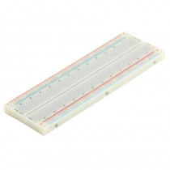 Wires 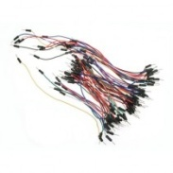 Temperature & humidity Sensor**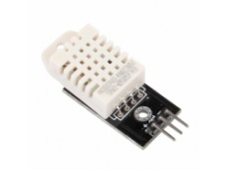

**Arduino UNO 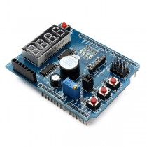 Soil Moisture sensor 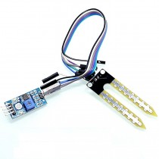 Bluetooth Device**